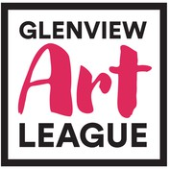

Robert Sherman Fine Art Scholarship Application

In 250-500 words, tell us what inspires you to create and to become a professional artist; what can you say with your art that you cannot say any other way?
Use additional pages if necessary.

Signature Date
*Note: Incomplete applications will not be considered.
: Family members and relatives of the Art League’s Board of Directors are not eligible.

Enclosed:

Completed application postmarked no later than March 30, 2024. Letter of recommendation from an art teacher.
Second letter of recommendation from a teacher or other adult who knows you well.
At least 10 images of your work, emailed to contact@glenviewartleague.org

Due by April 15, 2024:
Proof of college acceptance as a visual arts major.

Keep of copy of this application for your records.

